Automatic Brain Tumor Detection

Sadia Alam, Mohammad Abdullah, Syed Adiba Shuhin
BRAC University
66 Mohakhali, Dhaka, Bangladesh
{sadiaalam1007, spark8ab, adibashuhin}@gmail.com

ABSTRACT
We have observed that most of the fatal head diseases include brain tumor and brain hemorrhage. Both of which can be detected with image processing more accurately and automatically than the available alternative ways. Our goal is to develop an algorithm by which these diseases can be detected more precisely. We propose an automatic disease detection system with MRI Data using CPU parallel processing. The system will process collected MRI Data by which machine itself can detect the diseases. We are planning to use multi thread of CPU that will reduce the computation time of detecting diseases and increase efficiency. So our area of work is unsupervised Specifies in classification and prediction. Cover prediction of disease and image processing area.
KEYWORDS
brain tumor; brain hemorrhage; medical image processing; MRI data; segmentation; MRI pre-processing; disease prediction
1. INTRUDUCTION
Firstly, let’s talk about Brain tumor. It is one type of tumors (cancers). Abnormal neuronal cell with genetic mutation is the origination of this tumor. It is not easily diagnosed and depends on patients symptoms which varies e.g., headache, seizure, abnormal vision, vomiting, mental change, and unconsciousness which again depends on the location of the tumor[1]. Till now, Magnetic Resonance Imaging (MRI) and Computed Tomography (CT) scan are the main diagnosis tools for tumor detection including site and size examinations as a surgical approach. On the other hand Brain Hemorrhage is a type of stroke, it occurs when an artery in the brain bursts causing bleeding in the surrounding tissues. Nowadays normal MRI images are used to diagnose it. But even with a CT and MRI the identification of cerebral hemorrhage immediately is very tough. Therefore we need a certain method that can segment the MRI image quickly and automatically. Our goal is to obtain the image segmentation of brain bleeding more quickly and accurately. So patients with tumor and cerebral hemorrhage can immediately obtain medical treatment in accordance with the needs.
2. METHODOLOGY
The methodology we have followed in our system is given below:
2.1 DATASET
All MRI data is provided by the 2015 MICCAI BraTS Challenge. Each dataset contains four different MRI pulse sequences, each of which is comprised of 155 brain slices, for a total of 620 images per patient [2]. An example of a scan with the ground truth segmentation is showed in Figure 1. The labels of segmentation are represented as follows:
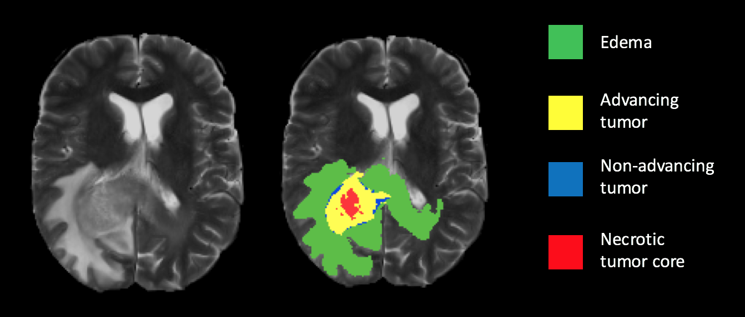
Figure 1: Ground truth segmentation overlay
2.2 Magnetic Resonance Imaging (MRI)
MRI is one of the most common diagnostic tools that use a magnetic gradient and radio frequency pulses to take repetitive axial slices of the brain and construct a 3-dimensional representation (Figure 2). Each brain scan 155 slices, with each pixel representing a 1mm3 voxel.
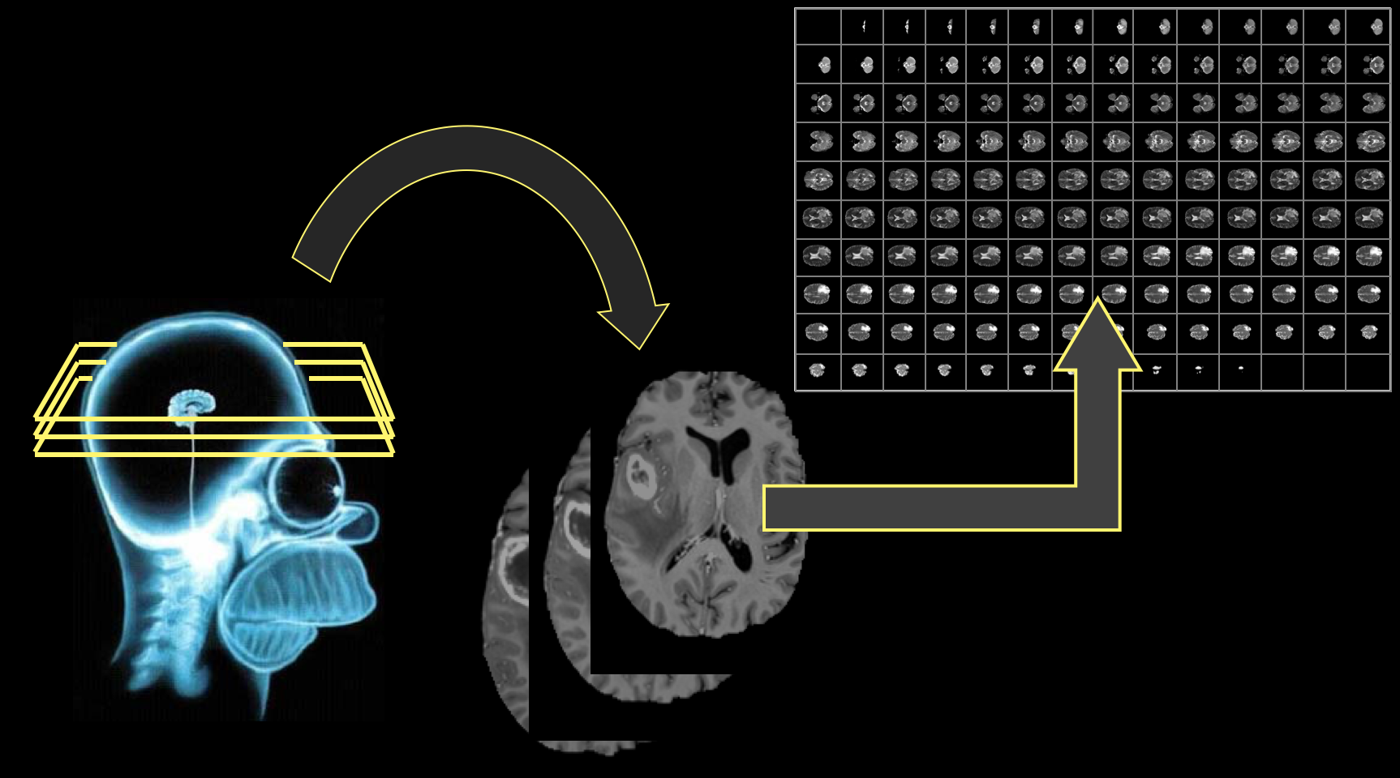
Figure 2: (Left) Basic MRI workflow. This is only one of four commonly-used pulse sequences used for tumor segmentation.
MRI pre-processing: Pre-processing is a crucial part of image processing. Here in our model pre-processing is needed to make the tumor more noticeable and detectable by increasing the intensity of the tumor higher and the other portion of the brain the same intensity lower than the tumor [3]. Thus, in pre-processing of the MRI images our model detects & eliminates the higher intensity of the data images accurately and in a time consuming way which can be a source of false positives [4].
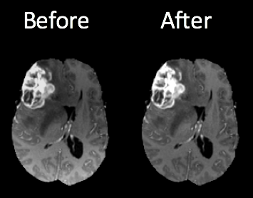
Figure 3: Brain scans before and after. The higher intensity is identified at the bottom of the image on the right.
Pulse sequences: Multiple radio frequency pulse sequences exists that can be used to illuminate different types of tissue, for adequate segmentation 4 different unique sequences are acquired: Fluid Attenuated Inversion Recovery (FLAIR), T1, T1-contrasted & T2 (figure 4)
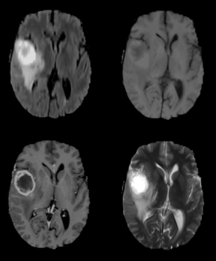
Figure 4: Flair (top left), T1, T1C and T2 (bottom right) pulse sequences.

Segmentation: approximately 600 images need to be analyzed per brain for a segmentation which has the potential to decrease lag time between diagnostic test and treatment [5].
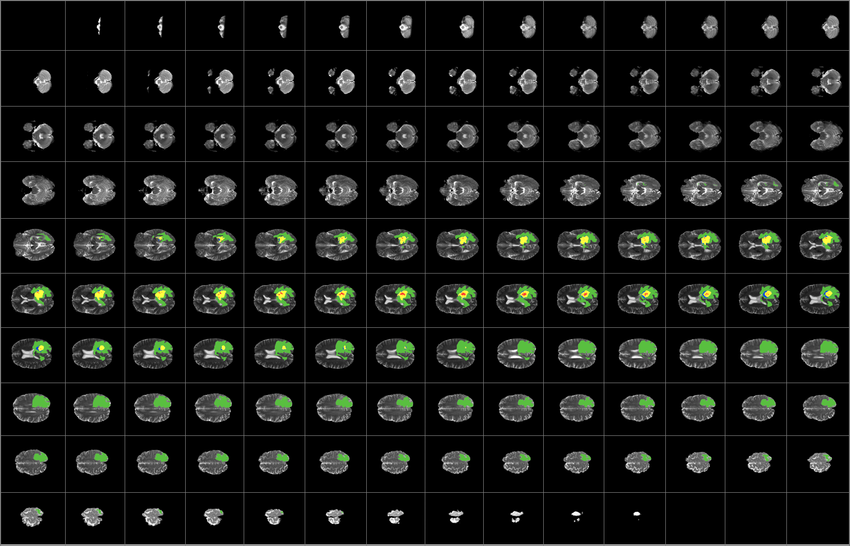
Figure 5: scans from each tumor imaging sequence in top. Approximately 600 MRI images are needed to analyze per brain for segmentation. The results of complete tumor segmentation are in bottom.
2.3 BRAIN SEGMENTATION WORKFLOW
The diagram of the work sequences of our model given below
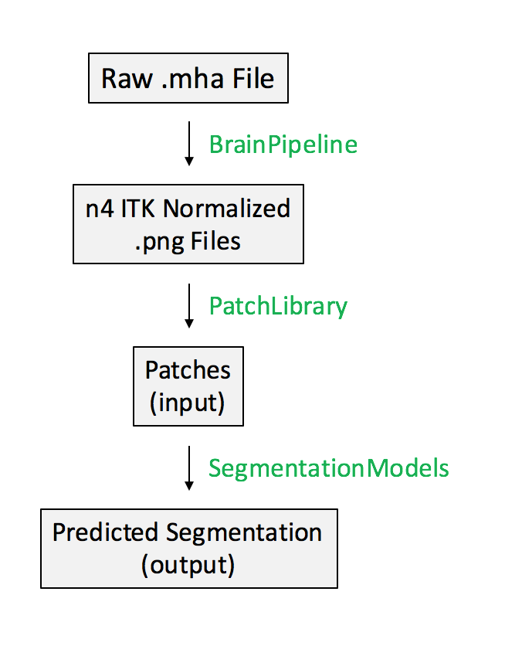
Figure 4: Segmentation Workflow
3. RESULT
Now we can summarize how well our model is predicting. This will update with time as we develop to next level. A representative example of tumor segmentation on test data is displayed in Figure 6. The model can identify each of the four classes with a good amount of accuracy, with the exception of class boundaries, which are smoother in my prediction than the existing processes.
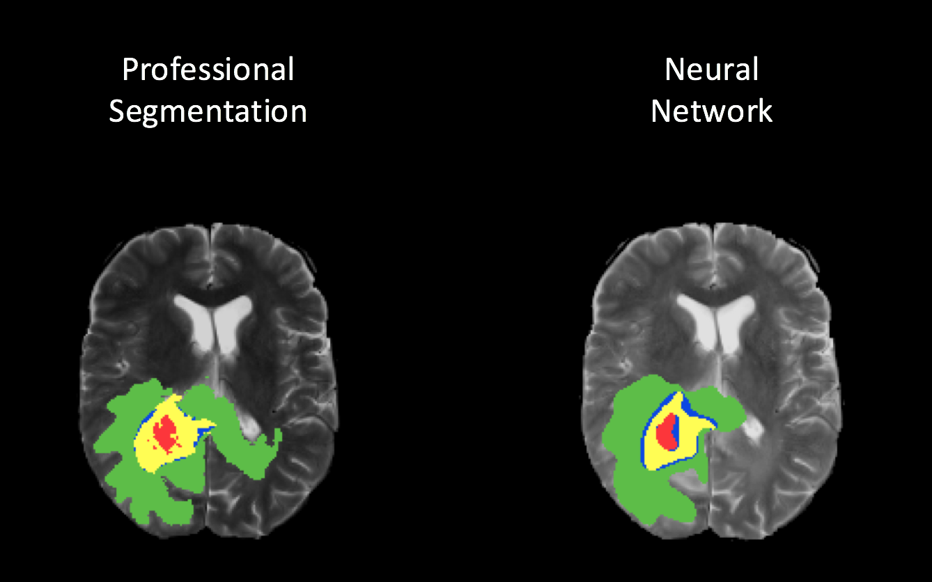

Figure 6: Results of CNN model segmentation on a single slice (top) with respect to the ground truth, and a 3D representation of the segmentation (bottom).
4. DISCUSSION
The density of tumor parts is different than the density of normal parts. We can detect the tumor by comparing this density difference. So by following density pattern we are detecting the abnormalities. In order to not let the program to be confused between tumor portion and normal portion we are per-processing all normal parts as even in normal part there could be little variance in density. The problem is in initial state the density variance is very little, So it becomes too hard to detect So even though the patient may have tumor due to the small size of it our program may not detect it. Yes we agree with the previous work but there were some obsolete methods that we replaced with updated ones. Making the process more precise and accurate after our experiment we get to know how much faster and easier the MRI process could be made and how will that be helpful.
5. CONCLUTION
By using python with appropriate libraries and with dataset we can solve a huge amount of complicated problems, in shortest time possible. Our problem is a good example of it. We made the way of tumor detection with MRI easier and more accurate and our program can let the patient know it self if he or she has tumor or not so a person can easily and possibly a bit earlier can know about his condition and go to doctor for treatment and in case of brain diseases this step could save thousands of lives.
6. REFERENCES

[1] Wikipedia Brain Tumor.
Retrieved from: https://en.wikipedia.org/wiki/Brain_tumor
[2] N. Aldeborgh, “Automatic Brain Tumor Segmentation”, 2017
Retrieved from: https://github.com/naldeborgh7575/brain_segmentation
[3] Phusomsal.W, So-In. C, Phaudphut. C, Chudgupta.T, and Punjanuk.W, “Brain tumor cell recognition schemes using image processing with parallel ELM classifications on GPU”, Computer Science and Software Engineering (JCSSE), 2016
[4] Balasooriya.U and M.U.S Perera, “Intelligent Brain hemorrhage diagnosis using artificial neural network”. Business Engineering and Industrial Applications Colloquium (BEIAC), 2012
[5] Vincy Davis, Satish Devane, "Diagnosis & classification of brain hemorrhage", Advances in Computing Communication and Control (ICAC3), 2017

